Intro

Note: This project involves large manipulation with the acquired data like storing the Excel sheet in database, detecting the column type, finding minimum-maximum, retrieving all unique values in categorical data – that is why we require working with pandas . So, to work efficiently with pandas we use sqlalchemy rarther than more manual ‘conn’ and mysql.connector
Why Use SQLAlchemy with Pandas?
SQLAlchemy is useful when working with Pandas and databases because it provides a high-level, flexible, and efficient way to interact with databases. Here's why it's better than using raw MySQL connectors:

-------------------------------------------------------------------Common queries------------------------------------------------------------------

The code is :
And here is short explaination :
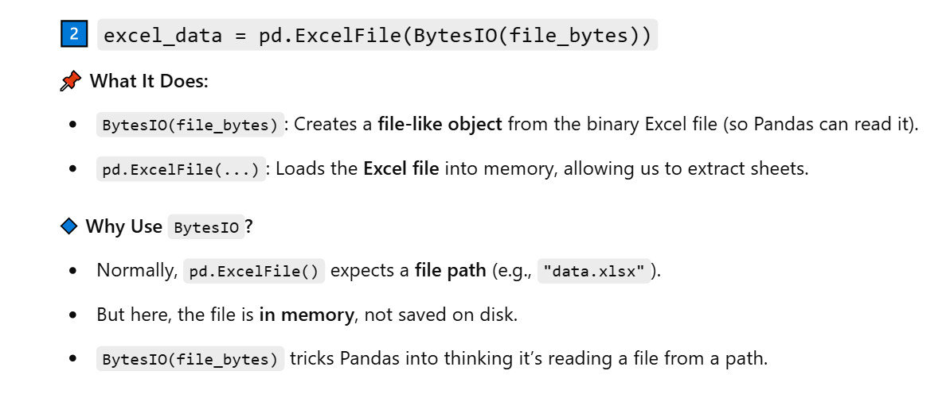

2. Diffrence between conn and engine
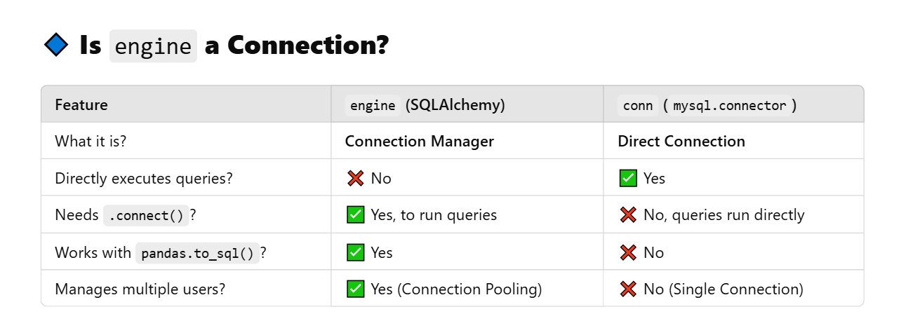
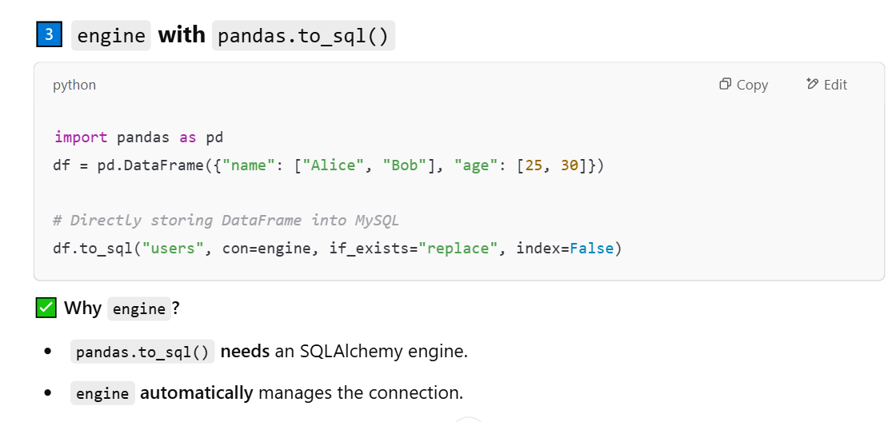
--------------------------------------------------------------------------------------------------------------------------------------
Server 1 : Storing the Data :
When storing the data using df.to_sql(sheet_name, con=engine, if_exists="replace", index=False
How SQLAlchemy Determines Types:
- Integer Columns → Stored as BIGINT
- Floating-Point Columns → Stored as DOUBLE
- Boolean Columns → Stored as TINYINT(1) (since MySQL doesn't have a direct BOOLEAN type)
- Date & Time Columns → Stored as DATETIME
- String Columns (object dtype in Pandas) → Stored as TEXT (default) or VARCHAR(255)

-------------------------------------------------------------------------------------------------------------------------------------
Server 2 : Categorizing data
What is pd.api.types?
pd.api.types is a submodule in Pandas that provides functions to check and manipulate data types in a DataFrame.

Why Use pd.api.types?
Normally, we check data types using: df.dtypes
But this gives general types like object, int64, float64, etc.
Instead, pd.api.types provides specific functions to check if a column belongs to a certain category, like numerical, categorical, or boolean.

Error : AttributeError: 'OptionEngine' object has no attribute 'execute'
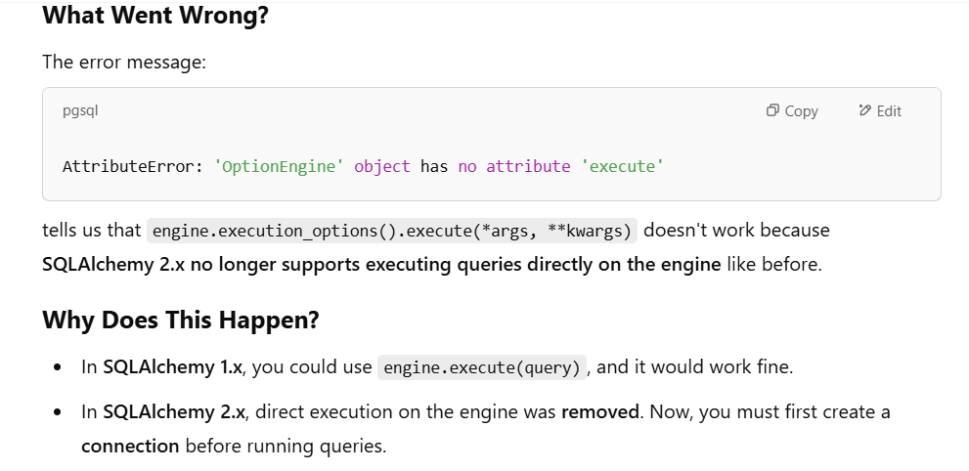
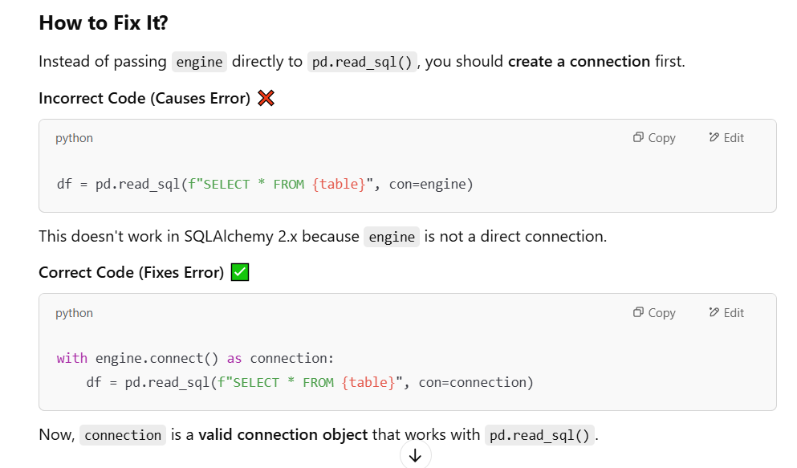
Why Does df.to_sql() Work?
python
CopyEdit
df.to_sql(sheet_name, con=engine, if_exists="replace", index=False)
✅ Works Fine
- df.to_sql() is designed to work with an engine object directly.
- Internally, pandas automatically creates a connection from the engine when writing data.
- SQLAlchemy manages the connection for you when writing.

Why Does pd.read_sql() Fail?
python
CopyEdit
df = pd.read_sql(f"SELECT * FROM {table}", con=engine)
❌ Throws Error in SQLAlchemy 2.x
- pd.read_sql() does not automatically create a connection in SQLAlchemy 2.x.
- In earlier versions (1.x), passing engine was enough, but in 2.x, you must explicitly create a connection.

The ‘database_metadata’ (output of categorize server) looks like this
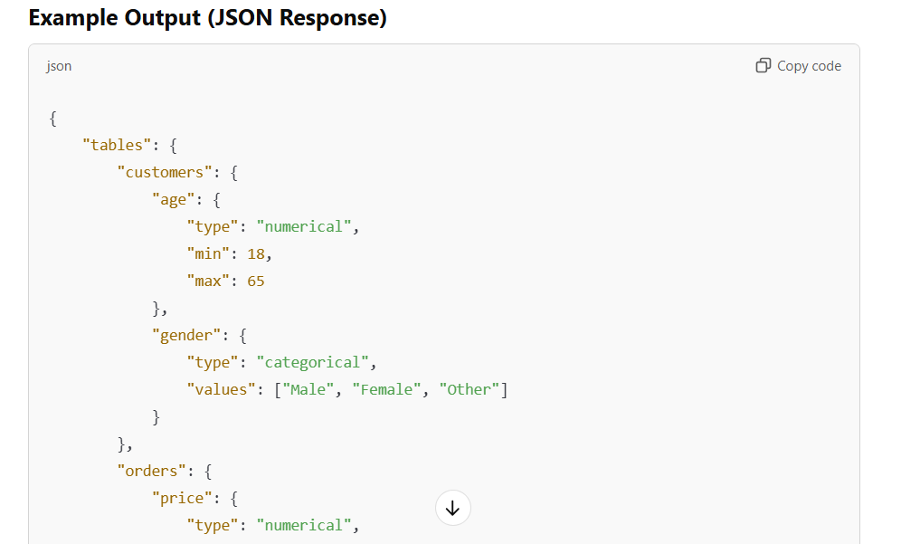

Javascript 1: Uploading excel file using frontend
The error is coming because MySQL treats table names as case-insensitive (on most systems) but Pandas' to_sql() method does not.
Step-by-Step Explanation of the Issue
- First Time Storing the Excel Sheets
  - Let's say your Excel file has a sheet named Teacher_Guardian.
  - When df.to_sql(sheet_name, con=engine, if_exists="replace", index=False) is executed, Pandas tries to create a table Teacher_Guardian.
  - However, MySQL (depending on its lower_case_table_names setting) automatically converts it to lowercase and stores it as teacher_guardian.
- Second Time Sending the Same Excel File
  - When you upload the file again, Pandas again tries to create Teacher_Guardian.
  - But MySQL already has the table stored as teacher_guardian.
  - Pandas tries to check if Teacher_Guardian exists, but MySQL only finds teacher_guardian, which is not an exact match in Pandas' view.
  - This mismatch triggers the warning:
UserWarning: The provided table name 'Teacher_Guardian' is not found exactly as such in the database after writing the table, possibly due to case sensitivity issues. Consider using lower case table names.

Why This Happens?
- MySQL handles table names in a case-insensitive manner by default.
- Pandas expects the exact table name to exist when writing to SQL.
- The difference in handling uppercase vs. lowercase table names leads to the warning.

Solution
To prevent this issue, always convert sheet names to lowercase before writing to MySQL:
python
CopyEdit
df.to_sql(sheet_name.lower(), con=engine, if_exists="replace", index=False)
---------------------------------------------------------------------------------------------------------------------------

Bootstrap used in filter.js and filter.html
🔵 Container & Layout
Class Name | What It Does
container | Centers the content and gives it proper left/right padding for responsiveness.
my-4 | Adds vertical margin (my) of 1.5rem above and below the element.
mt-4 | Adds top margin (1.5rem).
mb-3, mb-4 | Adds bottom margin (1rem for mb-3, 1.5rem for mb-4).
p-3 | Adds padding (1rem) on all sides.
shadow-sm | Adds a subtle box shadow for depth.
rounded | Adds slightly rounded corners.
d-flex | Makes the container a flexbox (used for checkbox layout).
flex-wrap | Allows wrapping of flex items onto multiple lines.
gap-3 | Adds space between flex items (1rem).

🟣 Typography & Text
Class Name | What It Does
text-primary | Gives the text a primary theme color (usually blue).
fw-bold | Makes the text bold.
text-muted | Makes the text gray and less visually prominent (used for notes/hints).

🟢 Form Controls
Class Name | What It Does
form-label | Styles <label> elements with spacing and font for consistency.
form-check | Wraps each checkbox and aligns label/input correctly.
form-check-input | Applies Bootstrap styling to checkboxes (padding, spacing, colors).
form-check-label | Styles the label for a checkbox.
form-control | Applies Bootstrap styling to input fields (width, padding, borders, etc).

✅ Summary
Purpose | Bootstrap Classes Used
Layout & spacing | container, my-4, mt-4, mb-3, mb-4, p-3, d-flex, gap-3, flex-wrap, rounded, shadow-sm
Typography | text-primary, fw-bold, text-muted
Form styling | form-label, form-check, form-check-input, form-check-label, form-control
---------------------------------------------------------------------------------------------------------------------------

It is necessary to define the render_response(response) function separately because if it is defined after the fetch(/categorize) request (after .catch()), then nothing will be shown as output because :
- Fetch is asynchronous – the content after the request (after .catch()) will be executed before the request is completed
- So the part needs to be called inside the request (inside .then()) - To simplify the code we just defined another function as render_response()

---------------------------------------------------------------------------------------------------------------------------
During the execution that is to happen when the form will be sumitted - document.getElementById("filterForm").addEventListener("submit", function (e) { }
The data is transferred in given format to the server
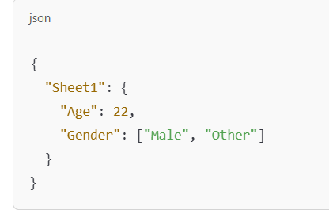
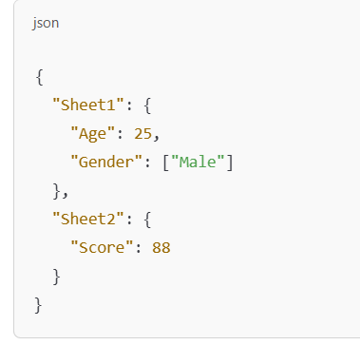
The data that was retrieved during the /categorize request earlier was also in the similar format


To also send the dbName along with the JSON to the server, we just need to attach it to the formData (JSON) object before sending it in the fetch() call Using a reserved key to store the dbName"
We're adding an extra key to the JSON object (formData) that doesn't represent a sheet or table — it's just meta-information we want to send along with the form data.

Why do this?
formData is structured like this:
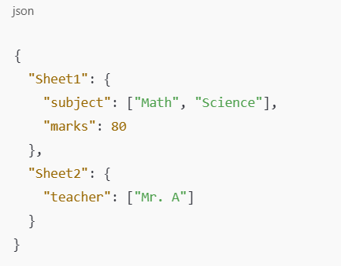

But now we also want to send the database name (like "college_database"). So we add it as a special field:
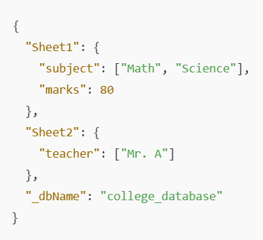
Notice the key is _dbName — starting with an underscore.
Why an underscore?
We use an underscore like _dbName to avoid naming conflicts with actual sheet/table names. We probably won't have a table named _dbName, so it’s a safe "reserved" label.
Reserved Key
“reserved key” isn't a special thing in Python or JSON by itself. It's just a naming convention we're using to avoid conflicts.
🔹 What "reserved key" means in this context:
We're sending a JSON object like this:
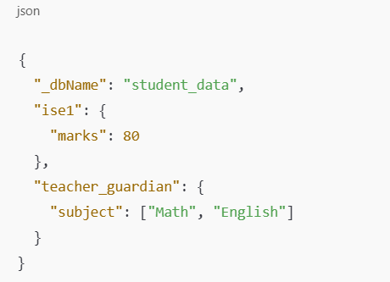
, "ise1" and "teacher_guardian" are table names.
To avoid mixing them up with actual table names, we prefix "dbName" with an underscore like this: "_dbName".
This is what we mean by a "reserved key":
A key that we define and reserve for internal logic, not actual database tables or filters.
🔹 Why use an underscore?
The underscore helps in two ways:
- Makes it less likely to collide with real table names.
- Acts as a signal to your code:
“Hey! Don’t treat this like a table — it’s a config option.”
🔹 Could you use a different name?
Absolutely! You can name it anything — just make sure your front end and back end agree on the name.
Common examples:
- _dbName
- __meta__
- __config__
- __options__

Making it Flexible (Optional Upgrade)
- We added on the frontend (like a dropdown or radio buttons) that lets the user choose AND / OR logic for combining filters, and send that preference to the backend as part of the JSON — like:
- It allows user to select their own combine logic
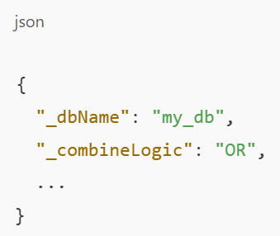
you can allow users to apply greater than (>), less than (<), equal to (=) constraints for numerical values. The JSON will finally look like this
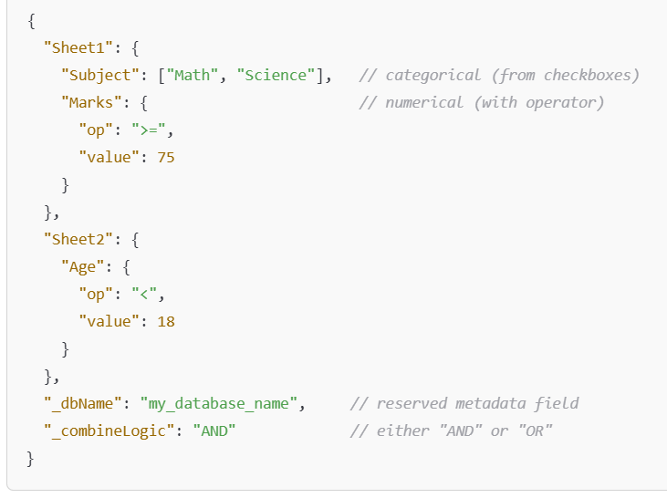
When user selects no checkbox or enter no range for numerical values then the json look like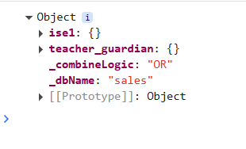
Where the {} of ise1 and teacher_guardian is empty (so the code will run only till JOIN clause – after building join clause it will automatically elimninate Where clause)
The generated query for the case looks like : SELECT * FROM ise1 JOIN teacher_guardian ON teacher_guardian.ID = ise1.ID

The JSON looks like the above beacuse
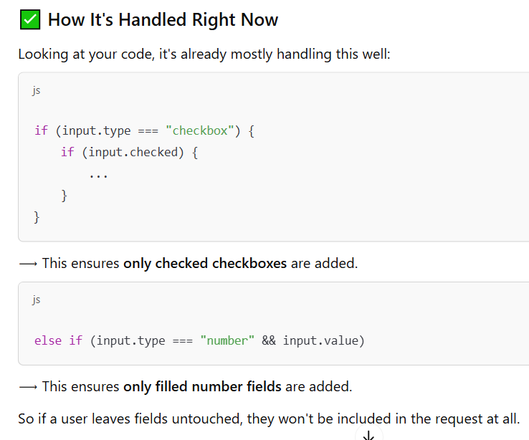

The code of backend to build the query is suitable for the case when user selects or enters nothing – We do that have to explicitly code for the case when ‘data’ received is empty after poping _dbName and _combningLogic
It is because :
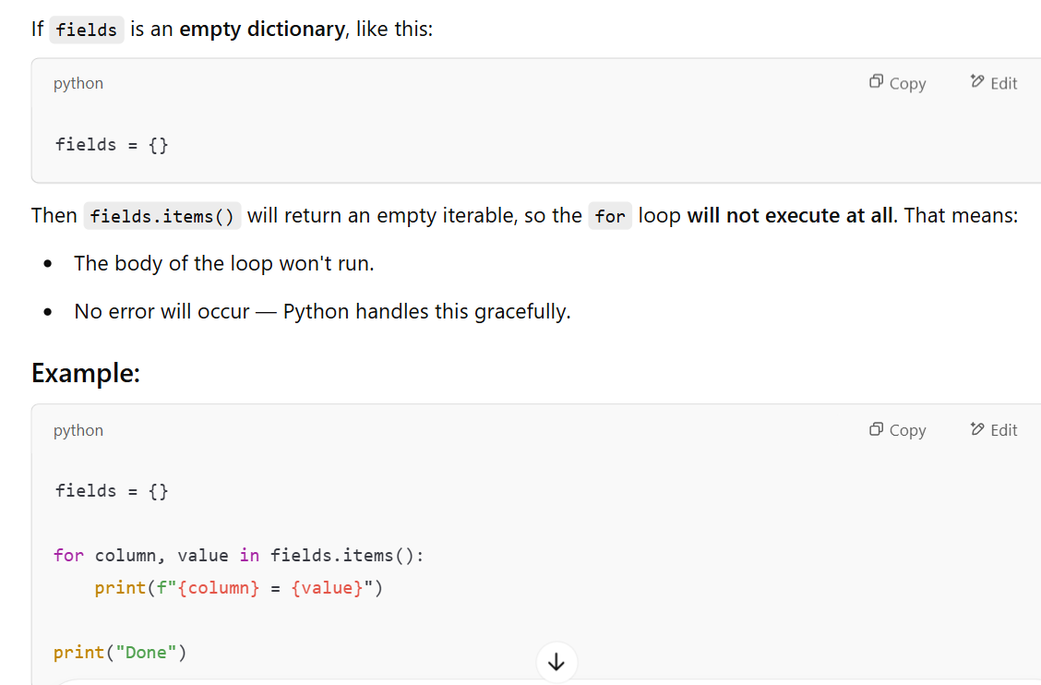

-------------------------------------------------------------------------------------------------------------------------
df = df.loc[:, ~df.columns.duplicated()] => keeps only the first occurrence of each column name and drops others. (removes duplicate columns)
🧩 Breakdown:
✅ df.columns.duplicated()
This checks which columns have duplicate names.
For example, if your DataFrame has columns: ['ID', 'Name', 'Subject', 'ID', 'Marks']
Then: df.columns.duplicated()
returns:[False, False, False, True, False]
It says: “Hey, the second 'ID' is a duplicate — ignore it.”

✅ ~df.columns.duplicated()
The ~ means "not" — it flips the True and False values.
So it becomes: [True, True, True, False, True]
Which tells pandas: "Keep only the first 'ID', and drop the second one."
✅ df.loc[:, <that result>]
This says: select all rows (:) and only the non-duplicated columns.
The full line: df = df.loc[:, ~df.columns.duplicated()]
→ It reassigns df to only have unique column names, keeping the first version of any duplicates.

